Employee

|  |
| --- |
| Eid |
| Ename |
| elocation |
| Ctc |
| Ectc |
| Notice period |
| Ph_num |
| E_email |
| Doa |
| App_status |

Company

|  |
| --- |
| cid |
| Cname |
| C_loc |
|  |

Job table

|  |
| --- |
| Job id |
| Position |
| J_loc |
| J_status |
| cid |

Join_company

|  |
| --- |
| Eid |
| jid |
| Doj |
| Ctc_offered |
| Join_status |
|  |

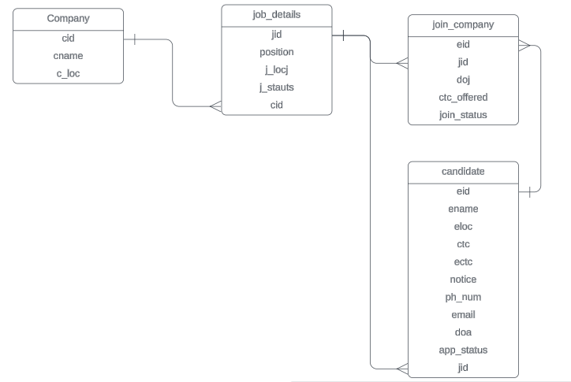

create database hrms;

show databases;

use hrms;

-- table creation

-- candidate table

create table candidate (eid int primary key, ename varchar(100), eloc varchar(100), ctc float, ectc float, notice varchar(10), ph_num decimal(10),email varchar(50) unique key, doa date, app_status enum ("pending","select","reject"),jid varchar(20), foreign key (jid) references job_details (jid));

-- company table

create table company (cid varchar(30) primary key,cname varchar(100),c_loc varchar(100));

-- job details

create table job_details(jid varchar(20) primary key, position varchar(50),j_loc varchar(100),j_status enum ("Open","Hold","Close"),cid varchar(30), foreign key (cid) references company (cid));

-- join company

create table join_company(

eid int, foreign key (eid) references candidate (eid),

jid varchar(20), foreign key (jid) references job_details (jid),

doj date,ctc_offered float, join_status enum("selected","joined","backout","drop")

);

show tables;

Candidate details

|  |  |  |  |  |  |  |  |  |  |  |  |
| --- | --- | --- | --- | --- | --- | --- | --- | --- | --- | --- | --- |
| eid | ename | e_loc | ctc | ectc | notice | ph_num | email | exp | doa | App_status | exp |
| 1 | Rahul Sharma | Mumbai | 250000 | 350000 | 1 month | 9764318264 | rahul@gmail.com | j1 | 2024-05-24 | reject | 2 |
| 2 | Pratik Gajne | Pune | 450000 | 650000 | LWD-12-08-2024 | 7946328640 | pratik@gmail.com | j2 | 2024-06-15 | select | 4.2 |
| 3 | Mansi Sharma | Delhi | 750000 | 1000000 | 2 month | 8765012349 | mansi@gmail.com | j4 | 2024-04-06 | reject | 5 |
| 4 | Priya Rane | Bangalore | 650000 | 850000 | 1 month | 8945320714 | priya@yahoo.com | j2 | 2024-05-01 | pending | 3 |
| 5 | Hemant Rathod | Pune | 105000 | 1400000 | LWD-26-09-2024 | 6842397011 | hemant@gmail.com | j3 | 2024-04-26 | pending | 1 |
| 6 | Tanya Mehta | Bangalore | 750000 | 1200000 | 1 month | 8523690174 | tanya@gmail.com | j1 | 2024-07-20 | pending | 5 |
| 7 | Preeti Yadav | Delhi | 750000 | 1000000 | 1 month | 739146028 | priti@redmail.com | j4 | 2024-07-20 | select | 4.5 |
| 8 | Joseph D | Noida | 480000 | 750000 | 1 month | 9761340280 | jd@yahoo.com | j3 | 2024-08-20 | pending | 3 |
| 9 | Sanjay Rathod | Pune | 105000 | 1400000 | LWD-15-10-2024 | 7530159846 | sanjay@gmail.com | j2 | 2024-08-04 | pending | 7 |
| 10 | Sneha Shetty | Bangalore | 480000 | 70000 | LWD-08-09-2024 | 7610349289 | sneha@gmail.com | j1 | 2024-08-24 | reject | 3 |

Company details

|  |  |  |
| --- | --- | --- |
| **cid** | **cname** | **c_loc** |
| c1 | Wipro Ltd | Mumbai |
| c2 | Deloitte | Bangalore |
| c3 | Capgemini | Delhi |

Job details

|  |  |  |  |  |
| --- | --- | --- | --- | --- |
| **jid** | **position** | **j_loc** | **j_status** | **cid** |
| j1 | Full stack java developer | Mumbai | Open | c1 |
| j2 | Automation tester | Bangalore | Hold | c2 |
| j3 | Devops Engineer | Pune | Close | c1 |
| j4 | Python Developer | Delhi | Open | c3 |